Lemonade Stand Game
Pure and Mixed Strategies:
Pure strategy: A player always chooses a particular action in every situation. In the context of this lemonade stand game, a pure strategy would be a specific position chosen by a player every time the game is played.
Mixed strategy: A player randomly chooses among a set of possible actions with specific probabilities.
Strategy 1: Random Strategy (randomStrategy()):
The first strategy implemented in the code is the random strategy. This strategy utilises the “positionGen()” function that is able to generate a number at random between 1 and 12 representing the different positions in the game for each player. This strategy resembles a real-life scenario where players would choose their positions at random if they were non-cooperative and each players payoff falls to luck, hence this strategy is also known as a “non-cooperative strategy”. In the case of this strategy this strategy also identifies as a “mixed strategy”.
Strategy 2: Equidistant Strategy (EquidistantStrategy()):
This strategy provides for the maximum and equal utility for each player every day. The general ideology being that the 1st player would pick its position at random, and the 2nd player would choose its position exactly 4 positions away from the previous player and this would continue as the last player would picks its position 4 positions from the 2nd player. This would ensure that all the players would be spaced out equally from each other hence resulting in each of their own utility to be exactly $8 per day.
This strategy is an example of a “cooperative strategy” as the second and the third player are dependent on each other as well as the first player but also there is no reason for any of the players to deviate from this strategy. This strategy is also an example of a “mixed strategy”.
Strategy 3: Opposite Side strategy (oppositeSideStrategy()):
This strategy is a unique strategy as it favours the 2 players that cooperate with each other. The working for this strategy goes as follows, the first 2 players choose their positions exactly opposite to each other(6 spaces between them) while the third player can randomly move to any position. The main aim being that the two opposite players always are at an advantage when it comes to the utility they receive each day, while the third player is always having the disadvantage.
This strategy is an example of a “cooperative strategy” between any two players as there is no reason for them to change their strategy. This strategy is also an example of a “mixed strategy”.
Strategy 4: Sacrifice Strategy (sacrificeStrategy()):
As the name implies this strategy exploits or ‘sacrifices’ 1 player and keeps its utility value at 2 each day while the other 2 players utility value reaches 11. To make this strategy work the 1st player must choose its position at random while the other 2 players position themselves to the left and right of the 1st player making them appear in a single straight line. This strategy could be hence considered as a “cooperative strategy” to increase the utility values of 2 players while diminishing the 1st player and there is no reason for the players adjacent to the middle one to deviate from its strategy. This is also an example of a “mixed strategy”.

Experimental Results and Analysis:
For the testing phase each strategy was executed twice for a total of 25 days
Run 1:
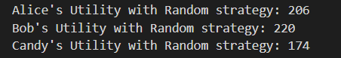 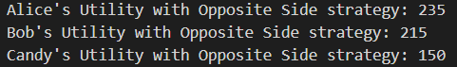
fig 1.2 fig 1.3
Run2:
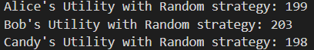 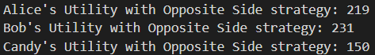
fig 1.4 fig 1.5
From figures 1.2 and 1.4 we can tell that the strategy has no clear distribution of one’s payoff. In fig 1.3 and 1.5 we can see that Candy repeatedly got the utility value of 150 after the end of 25 iterations for both the rounds while the other two player always ended with the higher payoff at the end.
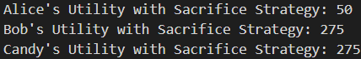 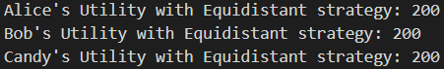
We can also note that the values for the “Sacrifice Strategy” and “Equidistant Strategy” remain constant as there would be no difference in the payoff values at the end of the 25 iterations.
Use and Updating for each strategy:
In the beginning all the players would be play at random positions for 25 iterations during which if at any point all their utilities on any day are all 8 then they would switch over to the equidistant strategy hence all of them would receive a utility value of 8 till the end of a 100 days forcing no player to deviate from that strategy. If at all after the 25 days 2 players want to better their chances in receiving a higher payoff for each day, they would be most likely to choose the Opposite side strategy where the utilities of the player at each of the opposite sides would be the highest compared to the third player. But on the occasion where 2 players share the same location, one of the players who got their shared utility as 6 would deviate from the strategy. So, for the next strategy 2 players would have to implement is the Sacrifice strategy where they would follow the player with the highest utility from the previous round and then sit adjacent to the left and right of that player. This would guarantee the adjacent players to receive 11 as their utility value each while diminishing the middle player to 2 for the rest of the game.
Equilibria in the Game:
Equilibria does only exist if all the players in the game get same the utility of exactly 8$ each day this could be achieved if they are all equidistant from each other or at the same position. Among the strategies written only using the “Equidistant Strategy” if played would result in the game being Equilibria. A Nash Equilibria only exists if they are equidistant from each other and not in the same position. Since a Nash equilibrium is a stable state in which no player has an incentive to deviate from their chosen strategy, if all other players also stick to their strategies hence this is only possible if all the players are equidistant from each other.
Conclusion and other AI approaches
Experimental studies includes gathering data from real players to assess their overall performance in the game. This would contain establishing controlled surroundings in which contributors may want to play the sport and file their choices. By accomplishing this type of studies, we will benefit perception into how human beings themselves method this sport and the techniques they use. This permits us to research the game designs and decide the great healthy for a character. Other AI processes like Reinforcement and Probabilistic reasoning can be carried out in the following ways. Reinforcement learning is a system getting to know method that includes an agent interacting with an environment to discover ways to make selections that maximise a cumulative reward. In the context of this recreation, the agent will be one of the players, and the environment might be the game board with the other players' positions. The agent would analyse through trial and error which moves to take based at the feedback received from the game board. While Probabilistic reasoning entails modelling unsure situations the use of probability theory. In the context of this recreation, probabilistic reasoning may be used to model the viable positions of the other players and make choices based at the probabilities of these positions hence modelling the uncertainty of the agent’s own position and updating the probability distribution as new information is available.

